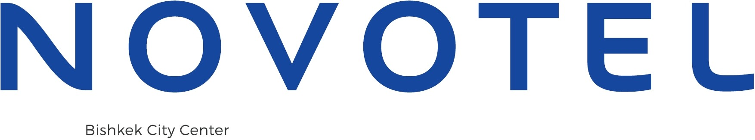

Name: Company: Telephone: E-mail:

From: Tel. No.: E-mail:

Reservation Department

+996 312 988 988

[HA145-RE@accor.com](mailto:HA145-RE@accor.com)

RESERVATION CONFIRMATION

**Hotel Reservation Form for Minex Central Asia**

Pleased complete all sections below and send this form directly to Reservation Department:

|  |  |
| --- | --- |
| **Guest Name** (Dr., Mr., Ms., Mrs., etc.): |  |
| **Number of Adults/Child:** |  |
| **Arrival Date:** |  |
| **Flight details/Time:** |  |
| **Departure Date:** |  |
| **Flight details/Time:** |  |
| **Airport pickup/drop off\*** (Yes/No): |  |
| **\*Please note that airport pick up or drop off is subject to additional charge (one way - 30$)** | |







|  |  |  |
| --- | --- | --- |
| **Room Type** | **Room Rate per room per night:** | **Check Box:** |
| *Standard Single* | 120 USD |  |
| *Standard Double* | 140 USD |  |
| **I would like to guarantee my booking**  (*If yes, we will send a link for payment to your e-mail address*) | |  |



|  |
| --- |
| We are pleased to confirm your reservation at Novotel Bishkek City Center. Here are the essential details:  Your room rate includes **12%** VAT, **2%** Sales Tax, and **2%** Service Charge.  As part of your stay, you'll enjoy complimentary Wi-Fi internet access and free car parking, subject to availability.  Check-in time is from **15:00** onwards. Early check-in before **15:00** is subject to availability and will inquire a **50%** charge of the daily room rate. Check-out time is by **12:00** Noon. Late check-out is possible subject to availability: a **50%** charge applies before **18:00**, and full rate after **18:00**. To avoid any cancellation charges, please inform us by **18:00** Bishkek time at least **24** hours before your expected arrival date.  We accept payment via Visa, MasterCard, American Express, China Union Pay, and Elcart. Please note that we only accept cash payment in the local currency (KGS), and we do not provide currency exchange services.  Kind Regards,  Novotel Bishkek City Center |

720010, Kyrgyz Republic • Bishkek, Manas Avenue, 16

T: +996 312 988 988 • F: +996 312 988 989 • [ha145@accor.com](mailto:ha145@accor.com)